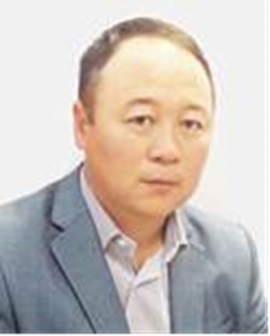  Umitkaliev Ulan Umitkalievich  Сandidate of historical sciences, Associate Professor  Contact details:  Corporate e-mail:  umitkaliyev_uu@enu.kz  Work phone:  +7(717) 2 709-500, int. (34-314) | Academic degree: candidate of historical sciences, decision of the Committee for Education and Science of the Ministry of Education and Science of the Republic of Kazakhstan dated May 4, 2011 (Protocol No. 4).  1996–2000 — Al-Farabi Kazakh National University, Faculty of History, major in “Archaeology and Ethnology”, obtained a Bachelor’s degree.  2000–2002 — Al-Farabi Kazakh National University, Faculty of History, major in “Archaeology and Ethnology”, obtained a Master’s degree.  2002–2004 — Al-Farabi Kazakh National University, Faculty of History, completed postgraduate studies in “Archaeology and Ethnology”.  2010 — Defended his Candidate of Historical Sciences (PhD equivalent) dissertation at the Institute of History and Ethnology named after Sh. Ualikhanov of the National Academy of Sciences of the Republic of Kazakhstan on the topic “The Contribution of A.M. Orazbaev to the Archaeology of Kazakhstan (Bronze Age)”.  2006–2012 — Associate Professor at the Department of Archaeology and Ethnology, Faculty of History, Al-Farabi Kazakh National University.  2013 – present — Head of the Department of Archaeology and Ethnology at L.N. Gumilyov Eurasian National University.  2024 — Awarded the academic title of Professor by the decision of the Ministry of Higher Education of the Republic of Kazakhstan.
Professional experience:
• 2013 - to present - Head of the Department of Archeology and Ethnology of the Eurasian National University named after L.N. Gumilyov;
• 2013–2013 - assistant, teacher, associate professor of the department of archeology, ethnology and museology of KazNU named after. al-Farabi;
• 2003–2006 - Engineer, junior, senior researcher at the Institute of Archeology named after A. Margulan (Almaty).
Awards:
- Certificate of honor from the Minister of Culture and Sports on the occasion of the celebration of the 550th anniversary of the Kazakh Khanate;
- Silver medal of the Academy of History and Social Sciences
Kazakhstan Republic of the Republic of Kazakhstan 25 medals,
- Medal “Kultegin”;
- holder of the title “Best University Teacher 2016”.
- Scholarship recipient of the International Presidential Program “Bolashak”, 2023.
Awards:
- Certificate of honor from the Minister of Culture and Sports on the occasion of the celebration of the 550th anniversary of the Kazakh Khanate;
- Silver medal of the Academy of History and Social Sciences
Kazakhstan Republic of the Republic of Kazakhstan 25 medals,
- Medal “Kultegin”;
- holder of the title “Best University Teacher 2016”.
- Scholarship recipient of the International Presidential Program “Bolashak”, 2023

